WEEK – 3
Spring Data JPA with Spring Boot, Hibernate

1) Spring Data JPA - Quick Example
Software Pre-requisites
- MySQL Server 8.0
- MySQL Workbench 8
- Eclipse IDE for Enterprise Java Developers 2019-03 R
- Maven 3.6.2

Create a Eclipse Project using Spring Initializr:
- Group: com.cognizant
- Artifact ID: orm-learn
- Description: Demo project for Spring Data JPA and Hibernate
- Dependencies: Select Spring Boot DevTools, Spring Data JPA, and MySQL Driver

MySQL Schema and table creation:
mysql> create schema ormlearn;
create table country(co_code varchar(2) primary key, co_name varchar(50));
insert into country values ('IN', 'India');
insert into country values ('US', 'United States of America');
Code :
*application.properties :
# Spring Framework and application log
logging.level.org.springframework=info
logging.level.com.cognizant=debug

# Hibernate logs for displaying executed SQL, input and output
logging.level.org.hibernate.SQL=trace
logging.level.org.hibernate.type.descriptor.sql=trace

# Log pattern
logging.pattern.console=%d{dd-MM-yy} %d{HH:mm:ss.SSS} %-20.20thread %5p %-25.25logger{25} %25M %4L %m%n

# Database configuration
spring.datasource.driver-class-name=com.mysql.cj.jdbc.Driver
spring.datasource.url=jdbc:mysql://localhost:3306/ormlearn
spring.datasource.username=root
spring.datasource.password=root

# Hibernate configuration
spring.jpa.hibernate.ddl-auto=validate
spring.jpa.properties.hibernate.dialect=org.hibernate.dialect.MySQL5Dialect
*Persistence Class – Country :
package com.cognizant.orm_learn.model;
import jakarta.persistence.*;
@Entity
@Table(name="country")
public class Country {
@Id
@Column(name="co_code")
private String code;
@Column(name="co_name")
private String name;
public Country() { }
public String getCode() {
return code;
}
public void setCode(String code) {
this.code = code;
}
public String getName() {
return name;
}
public void setName(String name) {
this.name = name;
}
@Override
public String toString() {
return "Country [code=" + code + ", name=" + name + "]";
}
}
*Repository Class – CountryRepository:
package com.cognizant.orm_learn.repository;
import org.springframework.data.jpa.repository.JpaRepository;
import org.springframework.stereotype.Repository;
import com.cognizant.orm_learn.model.Country;
@Repository
public interface CountryRepository extends JpaRepository<Country, String>{
}
*Service Class – CountryService:
package com.cognizant.orm_learn.service;
import java.util.List;
import org.springframework.transaction.annotation.Transactional;
import org.springframework.beans.factory.annotation.Autowired;
import org.springframework.stereotype.Service;
import com.cognizant.orm_learn.model.Country;
import com.cognizant.orm_learn.repository.CountryRepository;
@Service
public class CountryService {
@Autowired
private CountryRepository countryRepository;
@Transactional
public List<Country> getAllCountries() {
return countryRepository.findAll();
}
}
*Testing in OrmLearnApplication.java:
package com.cognizant.orm_learn;
import org.springframework.boot.SpringApplication;
import org.springframework.boot.autoconfigure.SpringBootApplication;
import org.springframework.context.ApplicationContext;
import com.cognizant.orm_learn.model.Country;
import com.cognizant.orm_learn.service.CountryService;
import java.util.List;
import org.slf4j.Logger;
import org.slf4j.LoggerFactory;
@SpringBootApplication
public class OrmLearnApplication {
private static final Logger LOGGER = LoggerFactory.getLogger(OrmLearnApplication.class);
private static CountryService countryService;
private static void testGetAllCountries() {
LOGGER.info("Start");
List<Country> countries = countryService.getAllCountries();
LOGGER.debug("countries={}", countries);
LOGGER.info("End");
}
public static void main(String[] args) {
ApplicationContext context = SpringApplication.run(OrmLearnApplication.class, args);
LOGGER.info("Inside main");
countryService = context.getBean(CountryService.class);
testGetAllCountries();
}
}
OUTPUT :
- Spring Initializr:
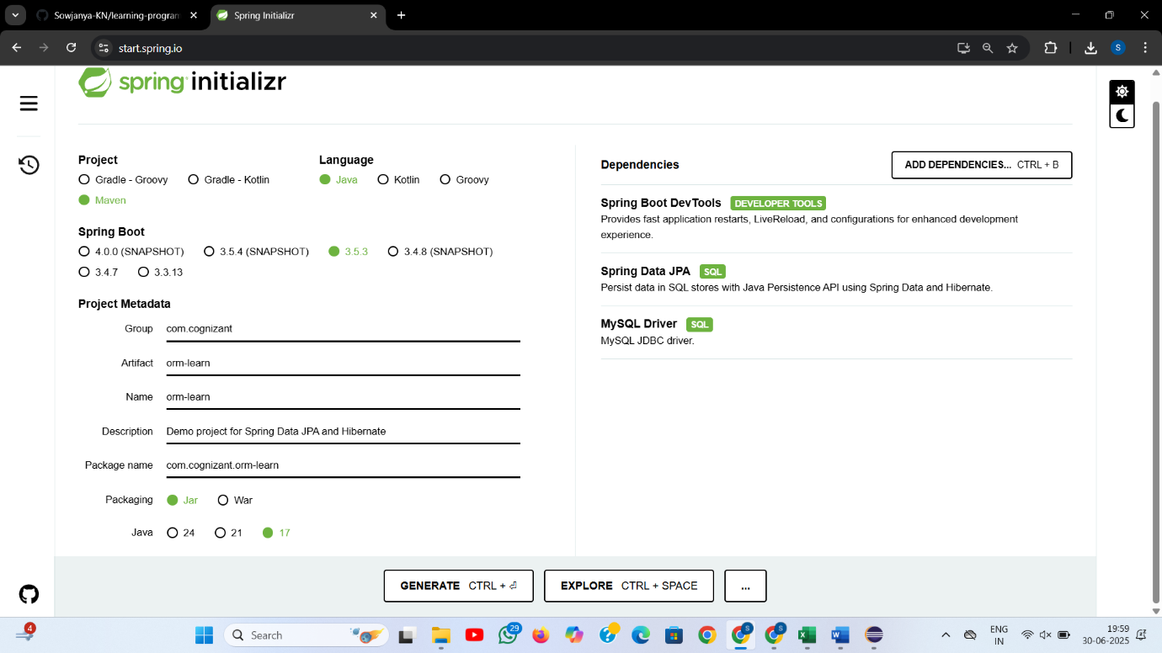
- application.properties
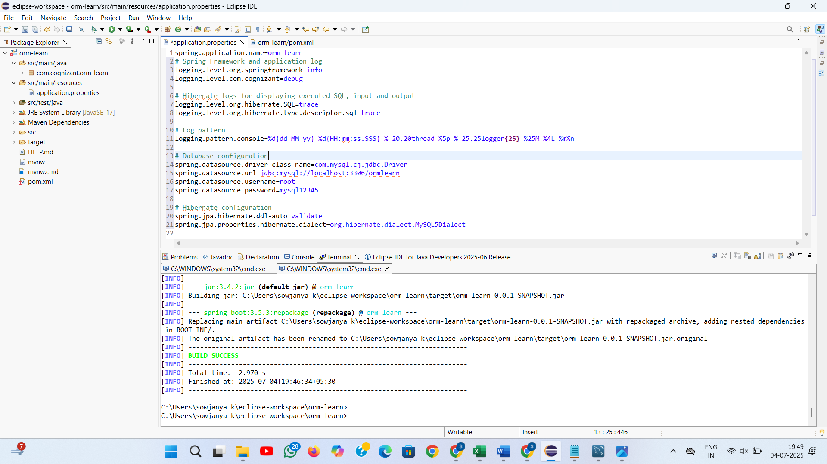

- MySQL Schema creation:

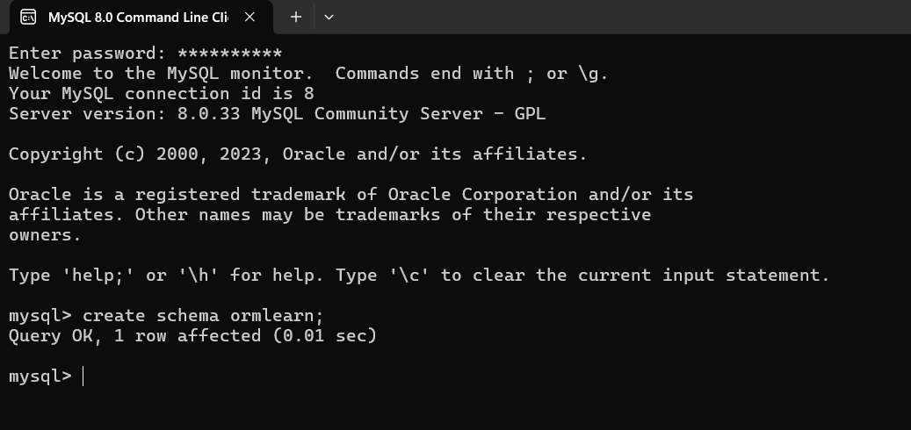

- Country table creation:

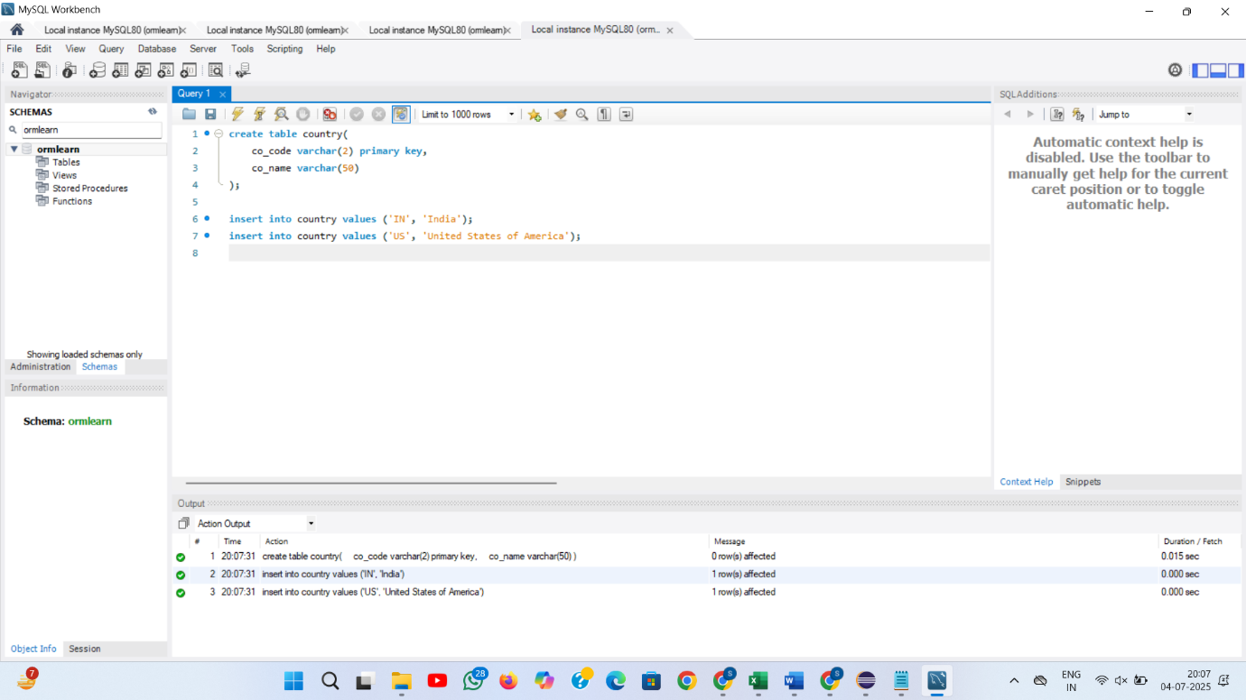

- Data from ormlearn database is retrieved :

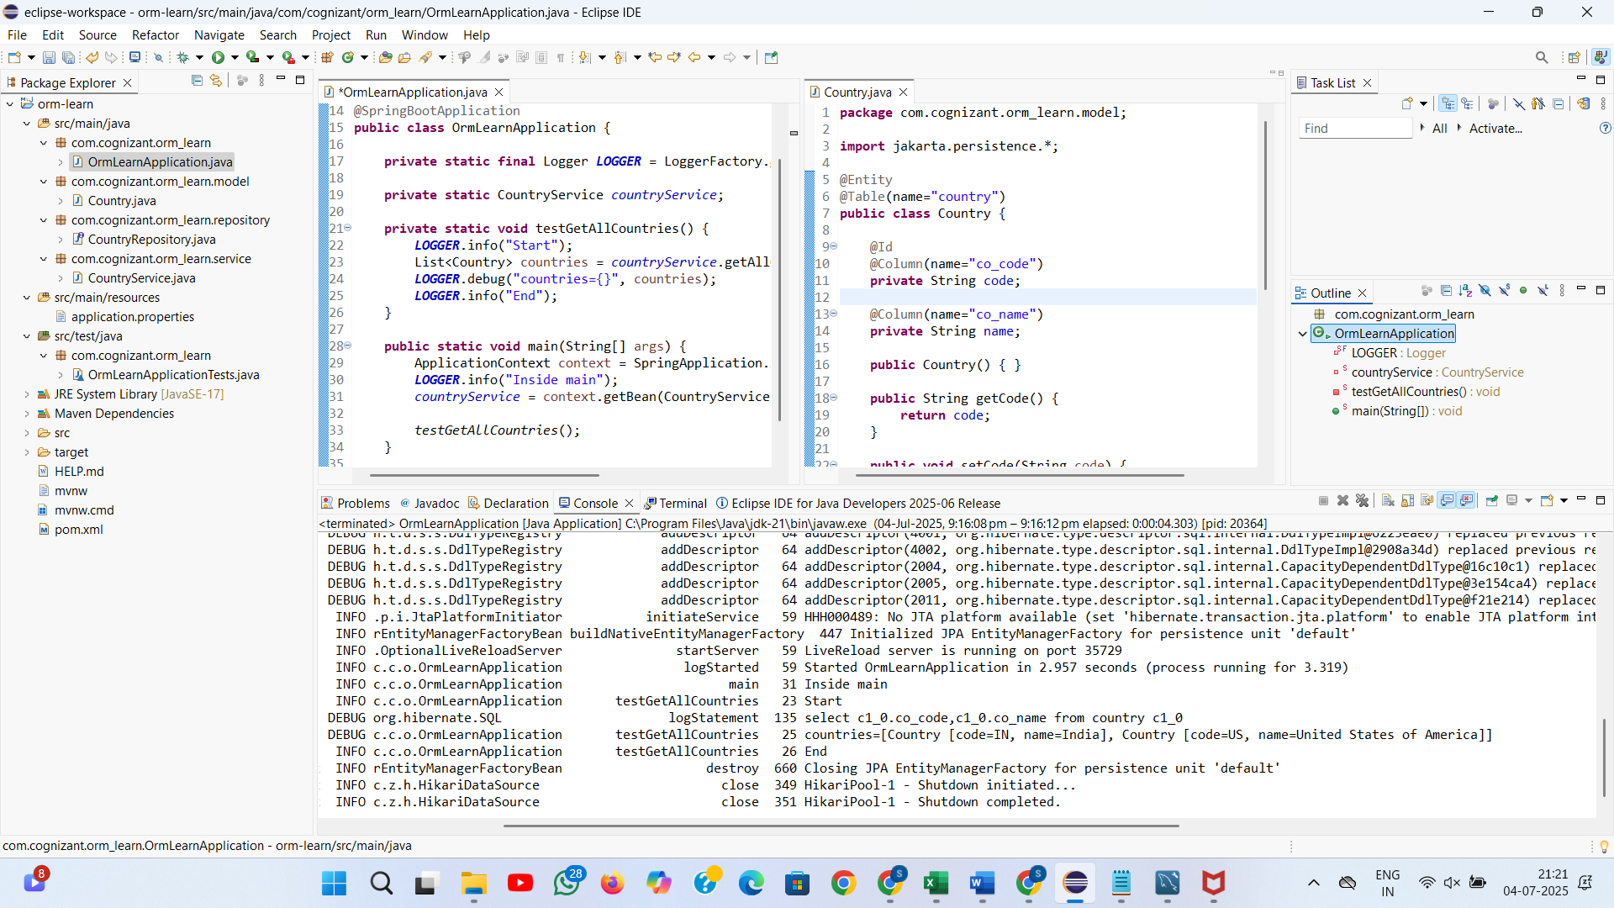

OUTPUT : countries=[Country [code=IN, name=India], Country [code=US, name=United States of America]]

2) Difference between JPA, Hibernate and Spring Data JPA:
Difference :
🔹 JPA (Java Persistence API)
- JPA is a specification, not an implementation.
- It defines how Java objects are mapped to database tables.
- Cannot be used directly — needs a provider like Hibernate.

🔹 Hibernate
- Hibernate is a popular ORM tool that implements JPA.
- Handles all SQL operations, caching, and transaction management.
- You need to write code to manage sessions and transactions manually.

🔹 Spring Data JPA
- It is a Spring module that builds on top of JPA.
- Removes boilerplate code like writing DAO classes.
- Just extend JpaRepository and Spring handles everything.
- Internally, it uses Hibernate (or any JPA provider).

Code snippets:
- Hibernate :
/* Method to CREATE an employee in the database */
public Integer addEmployee(Employee employee){
Session session = factory.openSession();
Transaction tx = null;
Integer employeeID = null;
try {
tx = session.beginTransaction();
employeeID = (Integer) session.save(employee);
tx.commit();
} catch (HibernateException e) {
if (tx != null) tx.rollback();
e.printStackTrace();
} finally {
session.close();
}
return employeeID;
}

- Spring Data JPA:
EmployeeRespository.java
public interface EmployeeRepository extends JpaRepository<Employee, Integer> {
}
EmployeeService.java
@Autowire
private EmployeeRepository employeeRepository;
@Transactional
public void addEmployee(Employee employee) {
employeeRepository.save(employee);
}
Difference in Code: Hibernate vs Spring Data JPA
🔹 1. Session Management
- Hibernate:
You have to manually open and close the Session using Session session = factory.openSession() and session.close().
- Spring Data JPA:
Spring automatically manages the EntityManager. You don’t write any session open/close code.

🔹 2. Transaction Handling
- Hibernate:
You manually begin and commit/rollback transactions using tx = session.beginTransaction() and tx.commit() or tx.rollback().
- Spring Data JPA:
You use @Transactional annotation and Spring handles transactions for you behind the scenes.

🔹 3. Boilerplate Code
- Hibernate:
You write a lot of repetitive code — session, transaction, exception handling, closing resources.
- Spring Data JPA:
No boilerplate code. Just call repository.save(entity) and Spring does everything.

🔹 4. DAO/Repository
- Hibernate:
You must write your own DAO classes and methods to save, update, delete, query data.
- Spring Data JPA:
Just create an interface that extends JpaRepository — Spring generates all CRUD methods automatically.

🔹 5. Exception Handling
- Hibernate:
You need to catch exceptions and handle rollback manually.
- Spring Data JPA:
Spring’s transaction manager handles exceptions and rollbacks automatically if @Transactional is used.

OUTPUT:

